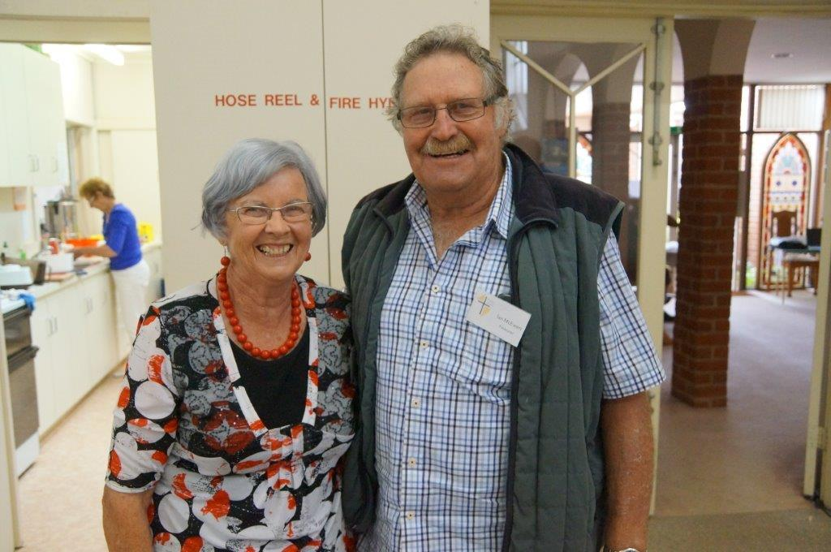
Joy

8 Sproats Lane
Donald Vic Australia 3480
Ph + 61 (0) 3 54971328
Fax + 61 (0) 3 54971908
Email: amc12370@bigpond.net.au
Skype: ian.r.mcewen
Webpage: mcewenfarming.com
to the world, the Saviour comes.
The Bethlehem Birth and subsequent life of Jesus Christ gives eternal meaning and purpose to earthly life. Without this ‘most significant event in history’ – quote CS Lewis, our story would not amount to much as the years speed by with seemingly increasing speed. However it is that time of year again and it is time to send out our annual family news and bring greetings from Donald and another dry, droughtish year, two in a row which is unusual. In the 60 + years of our farming career we have never had this happen.
The highlight for us was our trip of a lifetime, Three months and 22,000 kilometres drive through North America. The 15 families we stayed with, enjoying their hospitality was an extra special feature. Thank you families. As was all the beautiful places and scenic roads and the warm welcome from all. Our story is documented in our Blogg google < amc12370.wordpress >If you can’t access that get your grandkids to show you how!
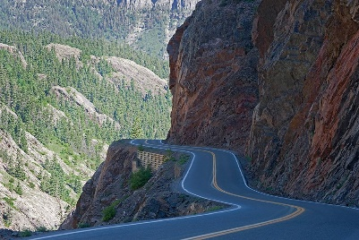
Million Dollar road in Colorado from Montrose to Durango and the scenic rail trip to Silverton just two of the highlights. We visited many relatives, former students, contacts met through Ukraine Fund activities and special friends we have met over our lifetime.
Ian was able to fill a wish to revisit with Alison, 3 special places he first saw in 1977 on a Farm Study tour. The Grand Canyon, Lake Louise and Banff in the Canadian Rockies and the Cowboy and Western Heritage Hall of Fame in Oklahoma and it took 38 years but we were able to accomplish that wish. Seeing the Colorado mountains, the Teton range and the Canadian Rockies with their snow peak tops brought many oos – ahs from the residents of the flat to undulating Wimmera regions.
Driving on the wrong side of the road was a bit of a challenge but we got through without a scratch in our Nissan Rogue SUV, thanks mainly to the latest `Tom Tom’ navigator that told us which lane to take and gave us a two mile warning for a turnoff . We needed it coming out of LA City there were 11 lanes both ways and one intersection between Dallas and Fort Worth in Texas had 5 levels of clover leaves
Grand Tetons 1

Figure 1Grand Tetons

Figure 2Grand Tetons



A friend we met on our Russian cruise from Sydney, Michelle, `house sat’ our home for the first month of our trip and we evidently escaped a very cold winter while we enjoyed warm to hot temperatures and clear skies.
Seeing Glenda and Clyde in Washington was very special as Glenda is not well. Glenda was an exchange student in 1982 and has been in touch ever since. We did appreciate staying with them for a week. Travelling in by train each day enabled us to see many of the sites of Washington. Glenda is working hard with her physio so she can have a greater measure of health than she has now.
Seeing our granddaughter, Renee (James and Grace’s daughter) in Invermere, Canadian Rockies was so special. Made all the more meaningful as Renee had been involved in a car accident two weeks before. Although her injures are healing, her friends have sustained injuries that require long term rehabilitation and the young driver lost his life. James, Grace, Hamish are joining Renee for Christmas.
Karin had the excitement of travelling to northern India on a short term mission trip. She had prepared educational materials, games and other activities and was surprised to see 3 year olds sitting formally in desks with no pre school program as we know it. The children loved the art and science activities that Karin had prepared. Karin enjoyed the kaleidoscope of colours, people, hope and beauty of India.
Rob and Marianne were kept busy with their work and moving house to Donvale, this year. Marianne finding the one level easier to manage. The family constantly on the go with Cassandra doing 3rd year Uni at Monash, hoping to be accepted into Honours year. Georgie doing VCE and Harrison, Year 9 with the extra curriculum activities of cadets, kayaking and Youth Group.
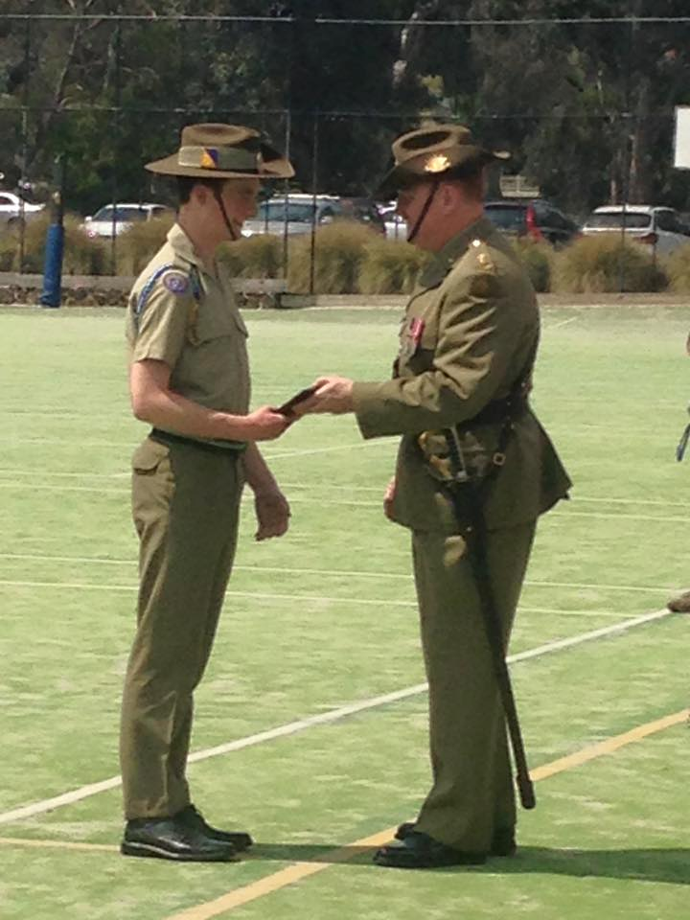
Top new recruit Harrison

Debbie keeps us informed with her adventures up north. Her work is always a challenge – fortunately or unfortunately, depending on the way you look at it, Tennant Creek has caught up with the quality assurance principles and Deb has been endeavouring to meet the auditing requirements, alongside patient care and hospital renovations. She managed to learn to play golf this year as her friend Andrew is a mad golfer. Having 3 of her children in the NT this year has meant a number of trips to Katherine. Olivia and Bill and his finance, Steph were all working on Pigeon Hole Station and Steph (Borden) left the coolness of Tasmania for the heat of the north and is working as case manager for the Dept of Social Service at Katherine. Rebekah is finishing her Graduate year of nursing in Horsham and is hoping to be employed by the Horsham Hospital. Levi and Hannah are in Kyneton. Hannah is enjoying her florist apprenticeship and Levi, his work in the timber yard. Alison’s brother, Neil is not well, which is a good excuse to travel to Melbourne and to see Neil and Sylvia and other family members.
[Grab your reader’s attention with a great quote from the document or use this space to emphasize a key point. To place this text box anywhere on the page, just drag it.]
Not the least of our special events for the year was our 50th Wedding Anniversary, celebrated with a luncheon in Melbourne with family and friends. We looked back over the years and wondered at God’s provision and blessing for us. Two different personalities living together with the ups and downs, enjoying their children and grandchildren, weeping with the pains of life but pushing on with the `next thing’ because the commitments of home, farm, church and community are ever calling and the `To Do’ list never ends.
We look forward to Church each Sunday as our pastor, Jono Ingram preaches with such maturity and wisdom we wonder what the Lord is challenging us with next. It is lovely to introduce new people to church these days.
Alison is involved with the Govt.’s push to do something to about the `Ice’ problem. Having been successful in obtaining a Grant, the involvement of achieving the objectives as set out in the Submission is challenging. The Group decided on competitions for website/facebook page/poster/short film. To ensure the criteria is right Alison has had to consult widely. But it will be worth it even if one young people says in his/her mind I will never touch it. The effects of Ice on the mind/body is horrific. The Ukraine Aid and Education Fund has big mile stone next Monday, the next Container of humanitarian goods leaves for Ukraine. Many months of collecting, packing and negotiating the paperwork accumulates with waving it good-bye!
Ian is enjoying his bowls! He loves the challenge and the fellowship of the other players. We are still involved with the convention and our regular Bible Study

We trust you have a lovely Christmas with family, as we too look forward to sharing Christmas with some of the family and friends.

Bowls
Cont
Convention
Neil

